**Institute of Technology Tralee**

**Computing Department**

**Object Oriented Programming 1**

**__________________________________________________**

**Tutorial 1 – Calculations and Decision-Making**

**(a)** Write a Java program that reads in the radius of a circle, r, and uses this to calculate its area, A. Note that the radius could be fractional here. The formula to do this is as follows:

$$A=πr^{2}$$

Ensure that you create $π$ as a constant in your program, setting it to 3.142

Your program would run as follows:

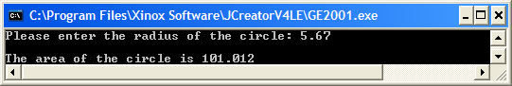

**(b)** Write a Java program that reads in a whole number of seconds and converts it into minutes and seconds. Note that there are 60 seconds in one minute.

Your program would run as follows:

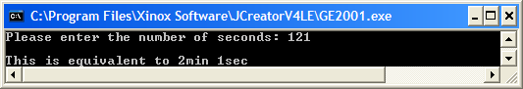

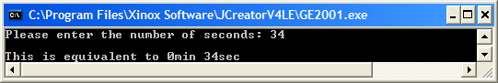

**(c)** Write a Java program that reads in two (possibly fractional) numbers and determines whether

* The first number is greater than, equal to or less than the second number
* The first number is exactly divisible by the second number
* Both numbers have the same whole part e.g. if the numbers were 13.45 and 13.89 then the numbers would have the same whole part (13)
* Either, both or neither number is negative

Some runs of the program are as follows:

